Pasco Wireless pH sensor
Run the Capstone software (1)
Double click the Capstone software icon on the desktop. From inside the Capstone software select the “Open Experiment” icon and then “Pasco pH Meter” on the desktop.

Connect wireless pH sensor (2)
Select “Hardware Setup” from the toolbar on the left edge. Turn on the pH meter, wait for the device number (located on the pH meter right of the Bluetooth symbol) to appear under the available wireless devices, and select to link. Click again on the “Hardware Setup” icon to close the box.

Calibrate the wireless pH sensor (3)
Select “Calibration” from the toolbar on the left edge.
Choose “pH” for the type of measurement you would like to calibrate then select “next”. The pH probe will appear as the default sensor.
Select a “Two Standards (2 point)” calibration then click “next”.
To calibrate the first point, set the standard value to 7.0 and present the pH 7.0 standard (be sure to rinse the electrode when presenting a new solution). When the “Current Value” stabilizes, click “Set Current Value to Standard Value” then click “next”.
Repeat for the second calibration point but set the standard value to 4.0 and present the pH 4.0 standard. Once set, click “next”.
Record the old and new slope and offset values in your notebook.
Select “Finish” to save the new calibration. If the calibration needs to be redone, select “cancel”.

Data Collection using the wireless pH sensor (4)
Click the “Record” button on the lower left to begin collecting data at 1.00 Hz.
To confirm the new calibration curve’s accuracy, measure the pH 4.0, 7.0, and 10.0 standards before each experiment and record these values in your notebook.
When the experiment is complete, select “Stop” to end data collection, then click “Delete Last Run”.

Disconnecting the wireless pH sensor
Under the “Hardware Setup” menu (2), click the black x to disconnect the electrode. Press and hold the power button for three seconds to turn the unit off. Screw the 3 M KCl solution back onto the cap before returning the electrode.

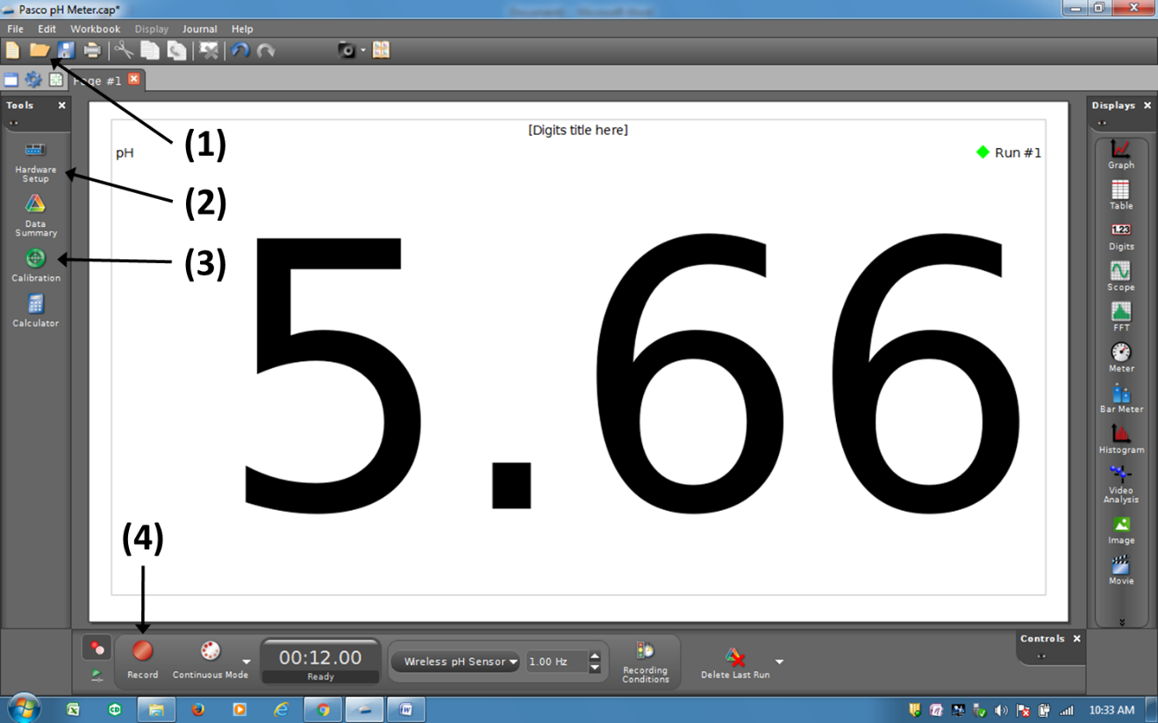

Electrode storage
Store electrode in pH 4 buffer with 1-10% added KCl.

